Sequential:

At this point, I've been fighting pointer matrices. I ran into an issue with running NxN where N>1023 for my sequential. This is because it exceeds the stack's size. I attempted to make it with pointers and utilize the heap, but at this point, it doesn't work yet so I included the working one without pointers.

To run the sequential:

compile with "gcc sequentialadd.c"

then run "./a.out [x]" where [x] is N

It will output a time it took to run in nanoseconds.

Parallel:

This thing is giving me massive issues with pointers, again.

Compile with “nvcc paralleladd.cu”

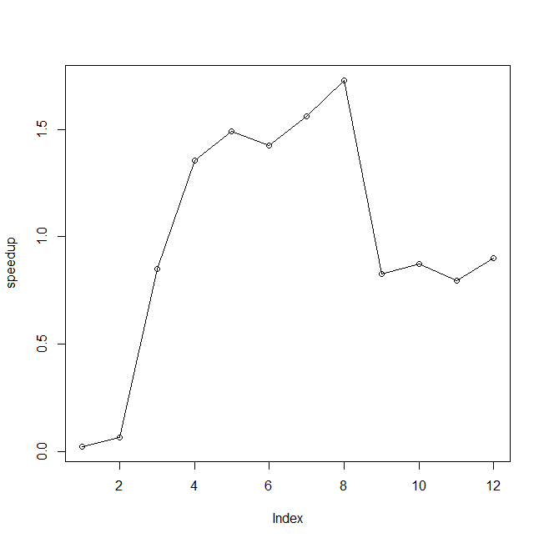Then submit the pbs that I included with “qsub cuda.pbs”

Speedup:

I’m not completely sure why it dropped off like it did. I’m assuming it’s due to the overhead.